Comparative Analysis of DeepFake Detection Techniques: CNN vs MesoNet

Abhinav Sharma
School of Computing Science and Technology
Bennett University
Greater Noida, India
aabhinav338@gmail.com
Sakshi Tomar
School of Computing Science and Technology
Bennett University
Greater Noida, India
tomarsakshi003@gmail.com

Abstract—The credibility of digital media is seriously threatened by the widespread use of deepfake technology. This resulted to the presentation of a wide range of detection methods, from customized deep learning architectures to traditional machine learning techniques.
Convolutional Neural Networks (CNN) and MesoNet are two deep fake detection models that are compared in this research study.The CNN model, a well-known machine learning technique, performs admirably, achieving an accuracy of 90.7%. But with an amazing accuracy of 95%, MesoNet—a lightweight neural network created especially for deepfake detection—performs better than the CNN model. In addition, MesoNet outperforms the bespoke CNN in terms of F1 scores, recall, and precision.Because of its specific architecture, which focuses on spotting tiny variations suggestive of deepfake manipulation, MesoNet performs better than other networks. In comparison, the CNN model is not optimized for deepfake detection; yet it is still effective.These results highlight the significance of using domain-specific models, like MesoNet, to stop the spread of deepfake content. We can improve the dependability and credibility of media integrity verification systems by utilizing customized designs designed to address the particularities of deepfake manipulation.
Keywords—Deepfake, Deepfake Detection, CNN, MesoNet.

Introduction
Digital photos and videos are increasingly utilized as everyday objects due to the popularity of smartphones and growth of social networks in recent years. Almost two billion photos are uploaded to the internet every day, according to many reports. Following the widespread usage of digital photographs there has been an increase in methods for manipulating the contents of images, such as using editing software like Photoshop. The recognition of image forgeries is the focus of the discipline of digital picture forensic research, which aims to control the spread of altered spread material. Several methods have been proposed to identify image forgeries [1], [2]. Most of these methods either extract image modifications from the final image or examine discrepancies in comparison to a typical camera pipeline. The detection of splicing, or the copy-past of one image onto another, has been demonstrated to be aided by image noise [3], among other factors. There are also some very helpful tips regarding image manipulation in the detection of image compression artifacts.
Natural language processing, computer vision, machine learning, and other sectors have all made use of deep learning, which is an extremely helpful and powerful technology. With the progress of deep learning, it is now [4] relatively easy to change digital content and produce synthetic content. Fake photos and videos are produced that are hard for people to tell apart from the real ones using deep learning algorithms and generative adversarial networks (GANs). Those models are trained on a dataset to generate fake movies and images, and they are generated utilizing huge data sets. Social media users can easily spread incorrect information and falsehoods that could have a negative impact on society thanks to the quantity of videos and photographs available there.
Nowadays, people are aware of the danger of fake news, and with over 100 million hours of video content viewed on social media each day, the proliferation of fraudulent information is a growing source of concern. Despite significant progress in photo forgery detection, digital video fraud detection remains a difficult issue. It is true that most techniques developed for photos cannot be used directly in movies, mostly because video compression severely degrades the frames. Though video re-encoding and video recapture [5] are the main areas of research for current video forensic studies [6], video edition is still difficult to find.

Moreover, Deep learning techniques have been effectively used for digital picture forensics in recent years. Other things, Barni et al. identify double JPEG compression locally on photos using deep learning. An image splicing detection network is proposed by Rao and Ni [7]. General fabrication of any image is the objective of Bayar and Stamm [8]. Computer graphics are distinguished from photographic images by Rahmouni et al. [9]. It is well known that traditional methods of signal processing are outperformed by deep learning in the field of digital forensics.
On the other hand, false videos can also be created through deep learning. A powerful new tool for face capture and procreation is called Deepfake. This method has never been covered in a scholarly publication; it was initially applied to the production of adult content. Deepfake is a real time computer vision technology that aims to achieve the same objective as Face2Face, a non-deep learning method described by Thies et al.

Deepfake images and videos are often shared on social media, according to recent studies. Consequently, the identification of deepfake photos and videos is becoming more and more crucial. Many deep learning techniques, such as Recurrent Neural Network (RNN) [2], Convolutional Neural Network (CNN) [3], and Long Short-term Memory (LSTM) [4], have been proposed to detect deepfake movies and images. Additionally, this will promote higher study in this field.
The deep fake detection algorithms that have already been put into action are the main subject of this work. It focuses on deep learning-based techniques like CNN and Meso-Net, as well as traditional detection techniques.

DeepFake

Introduction
The goal of the deepfake technique is to have someone else's face appear in a video in place of the targeted person's. It began life in the fall of 2017 as a script intended to create erotic videos in which people’s faces are switched. Subsequently, a tiny community refined this concept to notable effect, producing the user-friendly program Fake App.

Working for DeepFake
Two autoencoders are being trained simultaneously, which is the central notion. Their design may change according to the amount of output, the length of training that is needed, the expected level of quality, and the resources that are available. Traditionally, an auto-encoder signifies the connection of an encoder network and a decoder network. By converting the input layer data into fewer variables, the encoder serves the function of performing a dimension reduction [10]. Using those variables, the decoder then aims to produce an approximate version of the original input. Using a L^2 distance to penalize the difference between the input and its derived approximation, the optimization step is carried out. The original auto-encoder for the Deepfake techniques gets images with a resolution of 64 * 64 * 3 = 12,288 variables. After that, it uses 1024 variables to encode the photos, resulting in images that are the same size as the input.
Creating aligned faces of two distinct individuals, A and B, is the first step in creating Deepfake photos. Next, auto-encoders EA and EB are trained to rebuild A’s face from the dataset of A’s facial images and B’s face from the dataset of B’s facial images, respectively. To achieve this, the two auto-encoders, EA and EB, must share the weights of their respective encoding parts while maintaining independent decoders. When optimization is complete, any picture with an A face can be encoded using this common encoder and decoded using the EB decoder. Figure 1 provides examples of this concept.
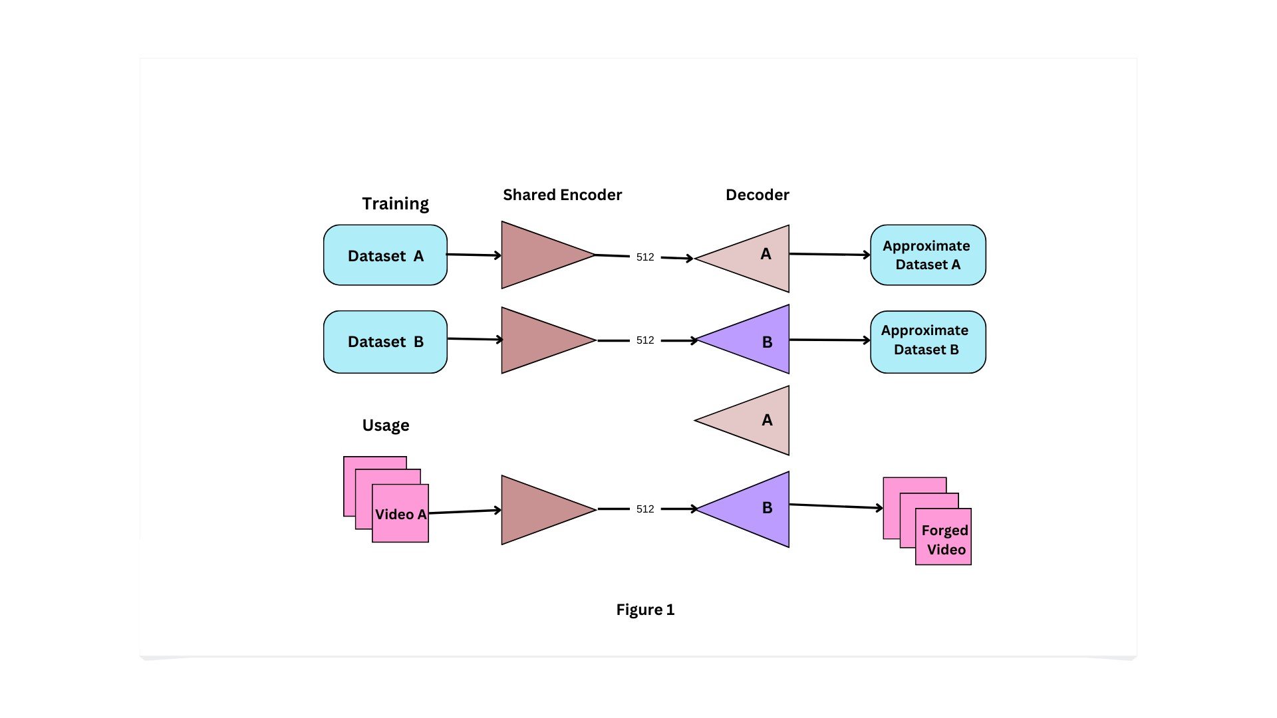

This approach is founded on the concept that every person should have a specialized decoder to reconstruct their constant characteristic forms and details of their own unique face, while generic information such as clarity, position, and expression is encoded by an encoder with privileges. Consequently, it may be able to discern between the contextual and morphological information.
. The technique's widespread popularity can be attributed to its impressive practical results. Taking the target movie, extracting, and aligning the target face from each frame, generating a new face with the same illumination and expression using the modified auto-encoder, and merging it back into the video is the final step.

Fortunately, there are many flaws in this method. Fundamentally, face extraction and reintegration can be problematic, particularly when there are face occlusions. This might result in certain frames having no facial reproduction at all, a significant amount of blur, or a duplicated facial contour. With more sophisticated networks, technical mistakes can be readily avoided. Furthermore, because autoencoders compress the input data onto a narrow encoding area, they often result in outputs that are somewhat fuzzy because they are unable to precisely reconstruct fine features. This also holds true for other applications. A bigger encoding space is not optimal because, although the fine features are undoubtedly better approximated, the final face becomes less realistic as it closely resembles the input face. This is an undesirable impact where morphological data are provided to the decoder.

Literature Review
Deepfake videos are becoming increasingly popular, and their illegal usage represents a severe threat to democracy, justice, and public trust. False video analysis, identification, and action are therefore becoming more and more necessary. Some terms that are related to deepfake detection are listed below:
A look for Face wrapping Artifacts in DF videos to reveal information [11] used a technique where a Convolutional Neural Network model created especially to identify artifacts is compared with generated face areas and associated regions. In this work of art there were two kinds of facial artifacts. They chose this method because the current DF technique can only generate images with a limited resolution; these images then need to be further processed to match the faces in the original image that need to replace.
Exposing AI Created forged films by detecting a novel method for exposing fraudulent face films created with deep neural network models. The method is based on the recognition of the flashing of the eyes in the films, a physiological signal poorly represented in computer generated imagery. The method is evaluated against benchmarks of eye blinking [12] detection datasets and shows how to detect Deepfake videos using Neural Networks. (IJSRD/Edition 8/Section 1/2020/221). All rights are held by www.ijsrd.com 1017, which offers a promising detection performance for videos created using software DF that is built on deep neural networks. Their detecting mechanism just looks for the absence of blinking. But to identify the deep fake, other factors like facial wrinkles and tooth enchantment must also be considered. We provide our strategy considering each of these factors.
Using a network of capsules, the method of “using capsule networks to detect forged images and videos” [3] identifies modified and forged images and videos in a variety of situations, including replay attack detection and computer-generated videos detection.
It is not advisable for them to incorporate random noise during the training phase of their technique. The model performed well on their dataset, but noise in the training set could still make it underperform when applied to real-time data. To train this approach, real-time and noise-free datasets are recommended.

Using the biological signals [13] technique, it is possible to identify synthetic portrait videos by obtaining biological signals from the face areas of both real and artificial portrait video pairings. To compute the temporal consistency and spatial consistency, record the signal attributes in feature sets and PPG maps, and train a CNN and statistical SVM, use transforms. The authority of the video is next discovered using the entire authenticity probabilities.
Regardless of the video's source, content, resolution, or quality, fraudulent Catcher has a high accuracy rate for identifying fraudulent material. Developing a differentiable loss function that conforms to the required signal processing steps is a challenging task since their outputs lose biological signal preservation when a discriminator is not included.

In their book Protecting World Leaders Against Deep Fakes, author Shruti Agarwal, Hao Li, and associates [14] outline the procedure for identifying mimics of leaders around the globe. It explains a forensic approach that imitates the motions and facial expressions typical of a person's speech pattern.
Darius Afchar, Isao Echizen, and others [10] present a technique for efficiently and subsequently detecting face alteration in recording or videos in their paper MesoNet: a Compact Facial Video Forgery Detection Network. It provides a way to effectively identify face fooling in recordings and focuses on particular on two recently created can produce incredibly realistic fake videos.
Robert Chesney and Danielle Keats Citron [15] examine the causes and effects of fake media producing unpleasant change in their study Deep fakes: Alooming threat for privacy, democracy, and national security.
They also investigate the instruments that are in use today and those that might be created in the future to address it. It aims to provide the first thorough analysis of the causes and consequences of this disruptive technical development associated with deepfakes, in addition to looking into alternative solutions.
The authors Zhou, Chen, and Wei use a transformer-based neural network architecture or an attention-based neural network to detect deepfakes in their study on multi-attentional deepfake detection [10]. This paper proposes a unique multi-attentional deepfake detecting network.
It consists of three fundamental components: 1) To make the network focus on different local locations, several heads require focal attention; 2) a textural feature augmentation block enlarges on small defects in shallow features; and 3) an aggregation of low-level textural features and high-level semantic features is generated using attention maps.

The authors of Limits of Deepfake Detection: A Robust Estimation [16] Agarwal, Varshney, et al. To identify deepfakes, Viewpoint uses a statistical technique free of any kind of deep learning processing or neural network deployment. To constrain the error probability for different GAN implementations, a robust statistical perspective of GANs is taken into consideration about their output.
In their study Exploiting Visual Artifacts to Expose Deepfake and Face Manipulations [17], Falko Matern, Marc Steiniger, and colleagues illustrated the state-of-the-art facial changing methods together with several distinctive artifacts from their processing pipelines. It also demonstrates how quite basic visual artifacts may already be extremely successful in revealing such manipulations, such as Face2Face and Deepfakes.
David Guera and Edward J. Delp [18] describe how recurrent neural nets (RNN) assess whether a video has been altered in their paper Deepfake Video Detection Using Recurrent Neural Nets. This study evaluates the method on a large set of deepfake films that were collected from multiple web video websites.
In ictu oculi: The writers Yuezun Li, Siwei Lyu, and colleagues [19] have clarified different methodologies by identifying eye blinks in the video recordings, a physiological indicator that isn't adequately shown in the combined fake video recordings. By identifying eye blinks, artificial intelligence was able to expose false video recordings. In addition to testing the algorithm on benchmarks of eye-blinking detection datasets, DeepFake-generated films demonstrate good performance in terms of detection.

Proposed Methodology

CNN
ConvNet, also known as the Convolutional Neural Network, is a specialized deep learning architecture that has received a lot of interest in the robotics and computer vision domains. Neocognitron, the original CNN concept, was first presented by Kunihiko Fukushima [20] in 1979 and is considered the precursor of contemporary CNNs. Later, Le-Cun et al. provided additional clarification on the CNN architecture, which prepared the way for the creation of improved iterations [21], including LeNet-5, which proved successful in classifying handwritten digits. Many well-known CNN architectures were analyzed for their fundamental parts and uses between 2012 and 2015 [22].

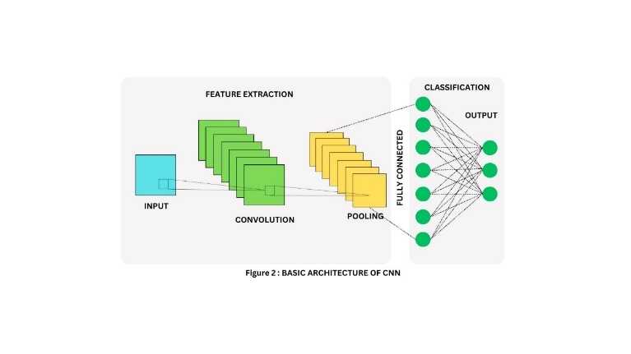
A CNN model is composed of three primary layers: convolutional layers, pooling layers, and fully connected layers. The primary job of the convolutional layer is to extract features. To do this, an elementwise product is used to apply a kernel, or array of numbers, across inputs, or tensors, to produce a feature map. Using various kernels, the convolution operation is applied to every element of the input tensor, producing several feature maps.

This convolution process is used in forward propagation during training, and descent of gradients is used in reverse propagation to update learnable parameters according to the loss value. Then, to find nonlinear features, nonlinear activation procedures like sigmoid, tanh, and ReLU are used. Down sampling is then used by pooling layers to lower the overall dimension of feature maps, providing translation consistency, and lowering the total number of variables that can be learned. The final predictions are produced by the fully connected layers at the conclusion of the CNN, with the number of output nodes equal to the number of classes in classification tasks. The CNN's prediction compatibility with the labels that reflect the ground truth is then measured using a loss function, which directs the optimization process to find the best-fitting parameters. Numerous sophisticated CNN models,[23] including AlexNet.

MessoNet
A lightweight neural network architecture called MesoNet was developed specifically for the detection of deepfakes in pictures and videos featuring human faces. To spot minute artifacts from deepfake creation techniques, it gathers intermediate-level characteristics. With its few convolutional and pooling layers, MesoNet [10] effectively strikes a compromise between computational load and accuracy, which makes it perfect for real-time applications and resource-constrained devices. It is essential for differentiating between authentic and altered content since it can identify irregularities in texture, lighting, and facial movements.

Our experiments began with quite intricate architectures, which we then gradually simplified to get at the next architecture, which yields the same results more effectively. This network consists of four sequentially organized layers of pooling and convolutions, followed by a dense network with one hidden layer. ReLU activation functions are used in the convolutional layers to improve generalization; Batch Normalization is used in the fully connected layers to regularize output and prevent the vanishing gradient effect; and Dropout is used to boost adaptability. This network has a total of 27,977 trainable parameters. Figure provides more information.

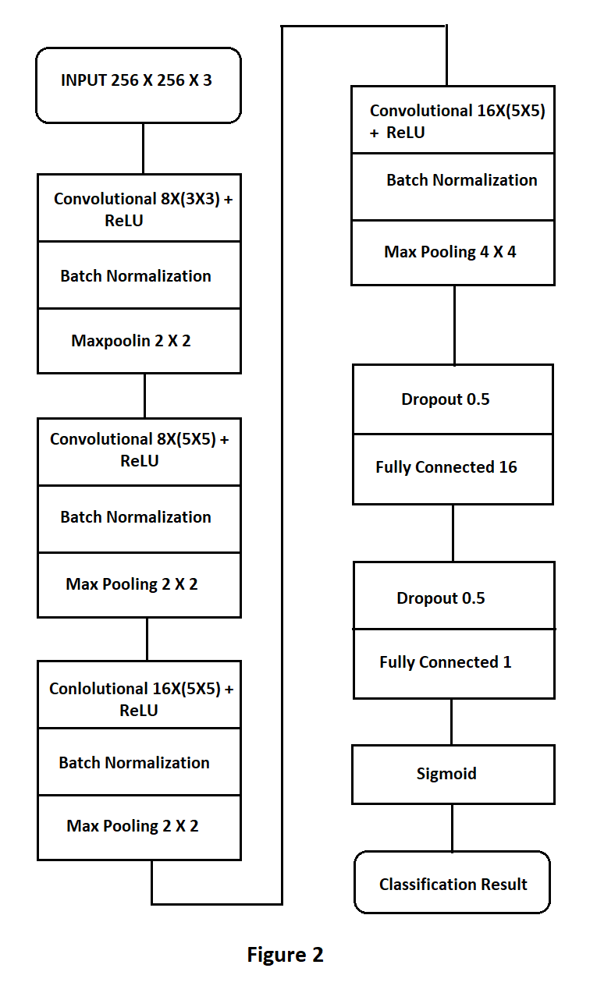

Dataset Description
Since no dataset has, as far as we are aware, collected videos produced using the Deepfake method, we have produced our own. For auto-encoders to produce realistic results in the forgery challenge, training with conventional processors must last several days and can only be done for two distinct faces at a time. Rather, we have opted to obtain the abundance of publicly accessible movies from the internet to have a wide enough variety of faces. As a result, 175 fake video rushes have been gathered from various platforms. Their minimum resolution is 854 * 480 pixels, and their runtime varies from two seconds to three minutes. Since each video is compressed with a distinct level of compression using the H.264 codec, our research is conducted under actual conditions.
All the faces were extracted using the Viola-Jones detector [24], and then they were aligned using a trained neural network for facial landmark detection [25]. To preserve a uniform distribution of faces, the number of camera angles and illumination modifications applied to the target face determines how many frames are selected for extraction from each video. For comparison, each scene had about fifty faces extracted.
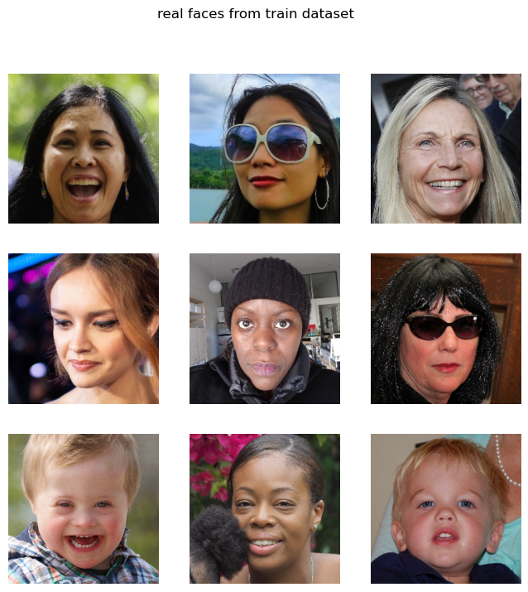

Then, genuine face photos that were likewise taken from other websites and had the same resolutions were added to double the dataset. To remove misalignment and incorrect facial detection, it has finally undergone a manual review. To prevent bias in the classification job, equally distributed photos with and without good resolution were utilized in both classes.

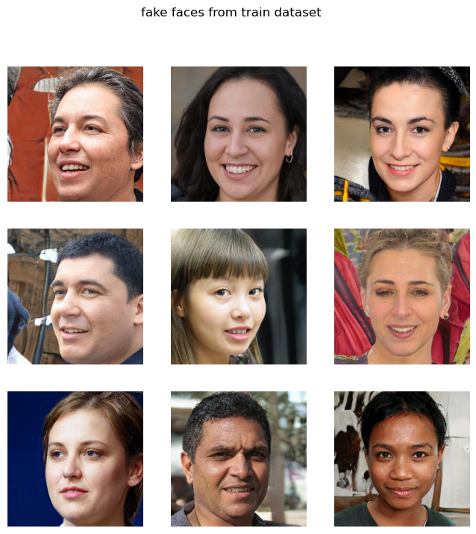

results
In this research paper we have proposed two models. Through this approach we are going to detect fake images that are different from the real images. We have used two models for the comparison to see which one is the best for detection and the results are clear for that.

CNN Results

First, we have used CNN, a machine learning approach in which we have applied different layers which effectively show the respected results. We have trained the model on 4 epoches and we got an accuracy up to 0.80 % and after saving the model it has reached to 0.90 % after increasing epochs by 2.

Below is the graph which shows the validation losses and the training losses:

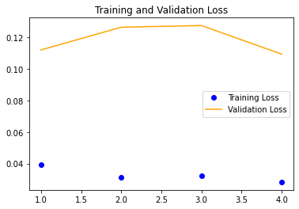
Confusion metrics of CNN model the clear result:
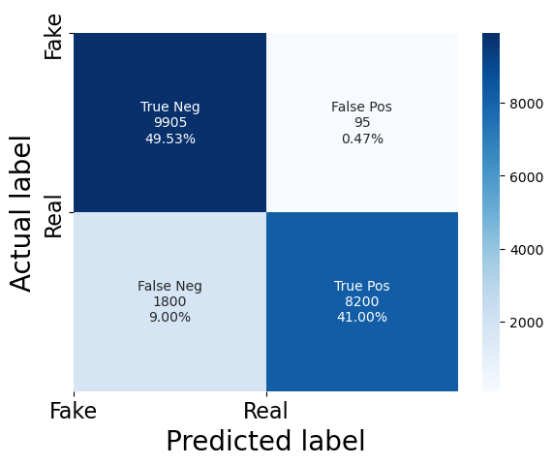

MessoNet Results
In the second model we have used a MessoNet for a comparison with the CNN model and the result shows the clear difference between two models. Here the accuracy was attained to 0.95% by increasing epochs to 10.

Below is the graph which shows the results between validation accuracy and the training accuracy:

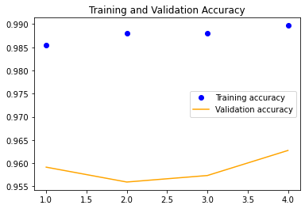
Confusion metrics shows the clear results:

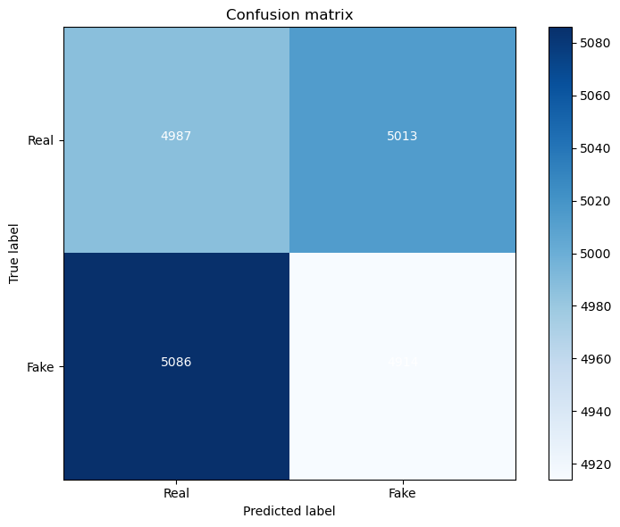

Comparison Table

Table showing the CNN Model used in research paper with different parameters used in this:

Models | Precision | F1 Score | Accuracy
CNN | 0.91 | 0.93 | 0.898

Below table shows the respected F1 score, precision, and Accuracies of both the models:

Models | Precision | F1 Score | Accuracy
CNN | 0.92 | 0.91 | 0.907
MessoNet | 0.90 | 0.92 | 0.952

Conclusion
To detect deep fakes, we contrasted MesoNet to a customized Convolutional Neural Network (CNN). With better accuracy, precision, recall, and F1 scores than the custom CNN, MesoNet performed noticeably better with an accuracy of 95 %. MesoNet's unique architecture—which is designed to identify minute modifications in deepfakes—is the reason for its better performance. Our results show the importance of using domain-specific models, like MesoNet, for trustworthy deep fake detection, emphasizing its greater effectiveness in maintaining media integrity compared to all-purpose CNNs.

References

- J. Bunk et al., “Detection and Localization of Image Forgeries using Resampling Features and Deep Learning,” Jul. 2017, [Online]. Available: http://arxiv.org/abs/1707.00433
- J. A. Redi, W. Taktak, and J. L. Dugelay, “Digital image forensics: A booklet for beginners,” Multimed Tools Appl, vol. 51, no. 1, pp. 133–162, Jan. 2011, doi: 10.1007/s11042-010-0620-1.
- T. Julliand, V. Nozick, and H. Talbot, “Image noise and digital image forensics,” Lecture Notes in Computer Science (including subseries Lecture Notes in Artificial Intelligence and Lecture Notes in Bioinformatics), vol. 9569, pp. 3–17, 2016, doi: 10.1007/978-3-319-31960-5_1.
- W. Wang and H. Farid, “Exposing Digital Forgeries in Video by Detecting Double MPEG Compression,” 2006.
- J. W. Lee, M. J. Lee, T. W. Oh, S. J. Ryu, and H. K. Lee, “Screenshot identification using combing artifact from interlaced video,” in MM and Sec’10 - Proceedings of the 2010 ACM SIGMM Multimedia and Security Workshop, 2010, pp. 49–54. doi: 10.1145/1854229.1854240.
- S. Milani et al., “An overview on video forensics,” APSIPA Transactions on Signal and Information Processing, vol. 1. Cambridge University Press, 2012. doi: 10.1017/ATSIP.2012.2.
- Institute of Electrical and Electronics Engineers, WIFS 2016 : 8th IEEE International Workshop on Information Forensics and Security : December 4-7, 2016, NYU Abu Dhabi, UAE.
- B. Bayar and M. C. Stamm, “A deep learning approach to universal image manipulation detection using a new convolutional layer,” in IH and MMSec 2016 - Proceedings of the 2016 ACM Information Hiding and Multimedia Security Workshop, Association for Computing Machinery, Inc, 2016, pp. 5–10. doi: 10.1145/2909827.2930786.
- N. Rahmouni, V. Nozick JFLI UMI, J. Yamagishi, and I. Echizen, “Distinguishing Computer Graphics from Natural Images Using Convolution Neural Networks.”
- D. Afchar, V. Nozick, J. Yamagishi, and I. Echizen, “MesoNet: A compact facial video forgery detection network,” in 10th IEEE International Workshop on Information Forensics and Security, WIFS 2018, Institute of Electrical and Electronics Engineers Inc., Jul. 2018. doi: 10.1109/WIFS.2018.8630761.
- K. Kulkarni, “DeepFake Detection: A survey of countering malicious Deep-Fakes,” Int J Res Appl Sci Eng Technol, vol. 10, no. 6, pp. 4492–4495, Jun. 2022, doi: 10.22214/ijraset.2022.44110.
- M. Russel Rudolf Richard, M. Shamanth, V. M. N, and A. Professor, “DETECTION OF FAKE FACES IN VIDEOS 1.” [Online]. Available: https://app.dimensions.ai
- U. A. Ciftci and I. Demir, “FakeCatcher: Detection of Synthetic Portrait Videos using Biological Signals,” Jan. 2019, doi: 10.1109/TPAMI.2020.3009287.
- S. Agarwal, H. Farid, Y. Gu, M. He, K. Nagano, and H. Li, “Protecting World Leaders Against Deep Fakes.”
- B. Chesney and D. Citron, “Deep fakes: A looming challenge for privacy, democracy, and national security,” Calif Law Rev, vol. 107, no. 6, pp. 1753–1820, 2019, doi: 10.15779/Z38RV0D15J.
- M. Russel Rudolf Richard, M. Shamanth, V. M. N, and A. Professor, “DETECTION OF FAKE FACES IN VIDEOS 1.” [Online]. Available: https://app.dimensions.ai
- F. Matern, C. Riess, and M. Stamminger, “Exploiting Visual Artifacts to Expose Deepfakes and Face Manipulations.” [Online]. Available: https://github.com/shaoanlu/faceswap-GAN
- D. Güera and E. J. Delp, “Deepfake Video Detection Using Recurrent Neural Networks.”
- Y. Li, M.-C. Chang, and S. Lyu, “In Ictu Oculi: Exposing AI Created Fake Videos by Detecting Eye Blinking.” [Online]. Available: http://bionumbers.hms.harvard.edu/bionumber.
- K. Fukushima, “Biological Cybernetics Neocognitron: A Self-organizing Neural Network Model for a Mechanism of Pattern Recognition Unaffected by Shift in Position,” 1980.
- Y. Lecun, E. Bottou, Y. Bengio, and P. Haffner, “Gradient-Based Learning Applied to Document Recognition,” 1998.
- S. Dong, P. Wang, and K. Abbas, “A survey on deep learning and its applications,” Computer Science Review, vol. 40. Elsevier Ireland Ltd, May 01, 2021. doi: 10.1016/j.cosrev.2021.100379.
- IEEE Computer Society., 2015 IEEE Conference on Computer Vision and Pattern Recognition (CVPR) : date, 7-12 June 2015.
- K. He, X. Zhang, S. Ren, and J. Sun, “Deep residual learning for image recognition,” in Proceedings of the IEEE Computer Society Conference on Computer Vision and Pattern Recognition, IEEE Computer Society, Dec. 2016, pp. 770–778. doi: 10.1109/CVPR.2016.90.
- P. Garrido, L. Valgaerts, O. Rehmsen, T. Thormählen, P. Pérez, and C. Theobalt, “Automatic face reenactment,” in Proceedings of the IEEE Computer Society Conference on Computer Vision and Pattern Recognition, IEEE Computer Society, Sep. 2014, pp. 4217–4224. doi: 10.1109/CVPR.2014.537.
IEEE conference templates contain guidance text for composing and formatting conference papers. Please ensure that all template text is removed from your conference paper prior to submission to the conference. Failure to remove template text from your paper may result in your paper not being published.

We suggest that you use a text box to insert a graphic (which is ideally a 300 dpi TIFF or EPS file, with all fonts embedded) because, in an MSW document, this method is somewhat more stable than directly inserting a picture.
To have non-visible rules on your frame, use the MSWord “Format” pull-down menu, select Text Box > Colors and Lines to choose No Fill and No Line.

